Project Design Phase-II
Technology Stack (Architecture & Stack)

Date | 09 July 2026
Team ID
Project Name
Maximum Marks | 4 Marks

Technical Architecture:
The Deliverable shall include the architectural diagram as below and the information as per the table1 & table 2
Example: Customer Registry App (CRM System) Architecture
Reference: https://developer.ibm.com/patterns/ai-powered-backend-system-for-order-processing-during-pandemics/
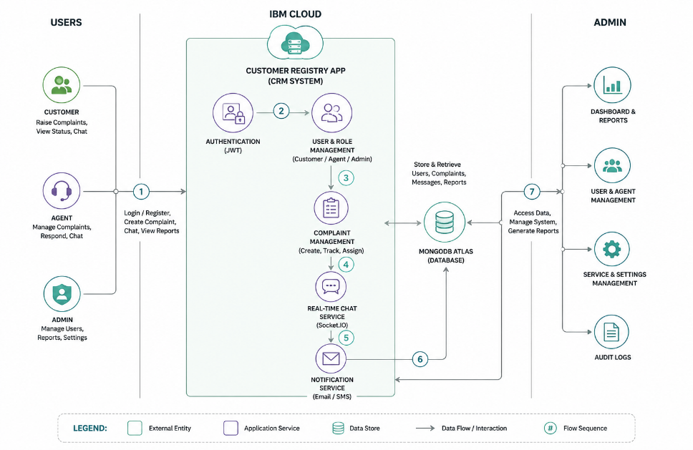
Guidelines:
Include all the processes (As an application logic / Technology Block)
Provide infrastructural demarcation (Local / Cloud)
Indicate external interfaces (third party API’s etc.)
Indicate Data Storage components / services
Indicate interface to machine learning models (if applicable)

Table-1 : Components & Technologies:
S.No | Component | Description | Technology
1 | User Interface | Web interface for customers, agents, and admins | React.js, Vite, HTML, CSS, JavaScript
2 | Application Logic-1 | User authentication and profile management | Node.js, Express.js, JWT, bcrypt
3 | Application Logic-2 | Complaint and agent management | Express.js, Mongoose
4 | Application Logic-3 | Real-time chat and notifications | Socket.IO, Nodemailer
5 | Database | Customer, complaint, and chat data | MongoDB Atlas
6 | Cloud Database | Cloud-hosted NoSQL database | MongoDB Atlas
7 | File Storage | Complaint attachment storage | Local Storage / Cloud Storage
8 | External API-1 | Email notification service | Gmail SMTP, Nodemailer
9 | External API-2 | Future service integrations | N/A
10 | Machine Learning Model | Not applicable | N/A
11 | Infrastructure | Application deployment environment | Render, Vercel, Localhost

Table-2: Application Characteristics:
S.No | Characteristics | Description | Technology
1 | Open-Source Frameworks | Frameworks used in development | React, Express, Node.js, MongoDB
2 | Security Implementations | Authentication and access control | JWT, bcrypt, RBAC
3 | Scalable Architecture | Three-tier MERN architecture | REST APIs, MongoDB Atlas
4 | Availability | Cloud deployment and high availability | Render, Vercel
5 | Performance | Fast UI and real-time communication | Vite, Socket.IO

References:
https://c4model.com/
https://developer.ibm.com/patterns/online-order-processing-system-during-pandemic/
https://www.ibm.com/cloud/architecture
https://aws.amazon.com/architecture
https://medium.com/the-internal-startup/how-to-draw-useful-technical-architecture-diagrams-2d20c9fda90d

